**Position Description**

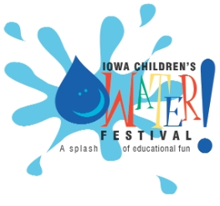

**2024 Iowa Children’s Water Festival**

**Coordinator**

The Iowa Association of Water Agencies (IAWA) is seeking a professional to serve as the 2024 Iowa Children’s Water Festival Coordinator. The successful candidate will possess an excellent ability to work with others, outstanding organizational skills, and be a proven leader. The contracted coordinator will interact with the Festival Steering Committee (FSC), IAWA board and staff, and event sponsors to successfully plan and carry out the 2024 Iowa Children’s Water Festival. The coordinator will be responsible for performing and ensuring FSC members have the guidance, assistance, and support required to complete all 2024 Festival-related tasks which include but are not limited to:

1. Managing school registrations;
2. Providing information to and responding to requests from schools and teachers;
3. Conducting marketing activities;
4. Reviewing state educational standards and updating materials as needed;
5. Arranging for all event facilities;
6. Completing an inventory of all materials and equipment;
7. Securing as donations and purchasing all items required;
8. Coordinating preparation and delivery of all materials and equipment;
9. Designing and printing all signage;
10. Ensuring health, safety, and emergency communications measures are in place;
11. Serving as on-site primary point of contact and coordination;
12. Coordinating cleanup and removal and storage of all materials and equipment;
13. Ensuring thank you notes are sent to sponsors;
14. Developing an event report and evaluation; and
15. Managing event finances with the IAWA treasurer

**Position Description**

**2024 Iowa Children’s Water Festival Coordinator cont.**

IAWA anticipates that compensation for the 2024 Iowa Children’s Water Festival Coordinator will be $15,000. Interested candidates are asked to submit a cover letter and resume by November 13, 2023 to Julie Smith, IAWA Executive Director, [julie.smith@brownwinick.com](mailto:julie.smith@brownwinick.com) . Questions can be directed to Julie Smith at the email address above. Visit these websites for more information about the Iowa Children’s Water Festival <http://www.iowachildrenswaterfestival.org/> and IAWA <http://www.iawa-water.org/> .